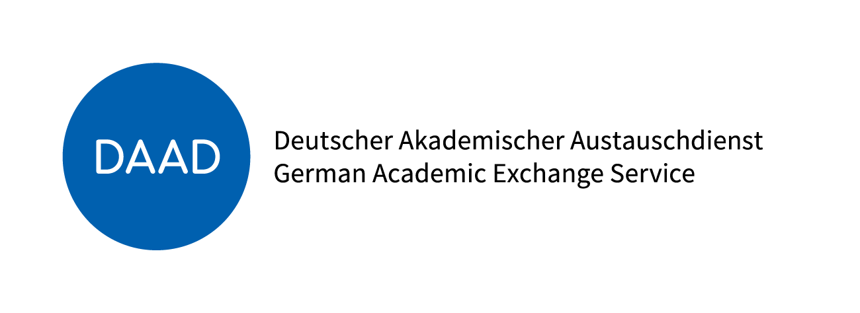
PROMOS Learning Agreement
Student Mobility for: ☐ Studies
☐ Traineeship/Internship

Academic Year 20__/20__

Student | Last name(s) |  |  |  | First name(s) |  |  |  | Date of birth | Nationality
 | Gender |  |  | Study cycle |  |  | Study Course
 |  |  |  | ☐ Bachelor ☐ Master
Sending Institution | Name |  | Country |  |  | Administrative contact person name; email; phone
 | Hochschule Neubrandenburg |  | Germany
Receiving Institution | Name |  | Faculty/Department |  |  | City, Country |  | Administrative contact person name; email; phone
DETAILS OF THE PROPOSED STUDY PROGRAMME ABROAD/LEARNING AGREEMENT
Course unit code  (if any) and page no. of the information package |  | Course unit title  (as indicated in the information package) |  |  |  |  |  |  |  |  | Number of ECTS credits
Fair translation of grades must be ensured and the student has been informed about the methodology.
If necessary, continue this list on a separate sheet.
Before the Mobility

We confirm that the proposed programme of study/learning agreement is approved.
Commitment | Name | Email | Place, Date | Signature
Student
Sending Institution: Hochschule Neubrandenburg
Departmental Coordinator
Institutional
Coordinator
Receiving Institution
Departmental Coordinator
Institutional
Coordinator
Commitment of the three parties
During the Mobility
CHANGES TO ORIGINAL PROPOSED STUDY PROGRAMME/LEARNING AGREEMENT
(to be filled in only if appropriate)
Course unit code  (if any) and page no. of the information package | Course unit title  (as indicated in the information package) | Deleted course unit | Added course unit | Number of ECTS credits
☐ ☐
☐ ☐
☐ ☐
☐ ☐
☐ ☐
☐ ☐
☐ ☐
☐ ☐
If necessary, continue this list on a separate sheet.

We confirm that the changes to the proposed programme of study/learning agreement are approved.
Commitment | Name | Email | Place, Date | Signature
Student
Departmental Coordinator at the Sending Institution
Departmental Coordinator at the Receiving Institution
Commitment of the three parties
After the Mobility
COMPLETED STUDY PROGRAMME - ACHIEVED PERFORMANCE
(to be filled in only if appropriate)
Course unit code  (if any) and page no. of the information package | Course unit title  (as indicated in the information package) |  |  |  | Number of ECTS credits | Local Grade
If necessary, continue this list on a separate sheet.
Duration of stay at the Receiving Institution/Enterprise
Name of the Student/Trainee
Address of the Receiving Institution/Enterprise
Start date and end date of the complete study time/traineeship |  |  | From [Day/Month/Year] | To [Day/Month/Year]

Signature of the Supervisor at the Receiving Institution
Date, Signature, Stamp

